Custom Excel Sheet Upload Task Process Workflow

The Excel worksheet is uploaded using an html/javascript as shown below

Te the

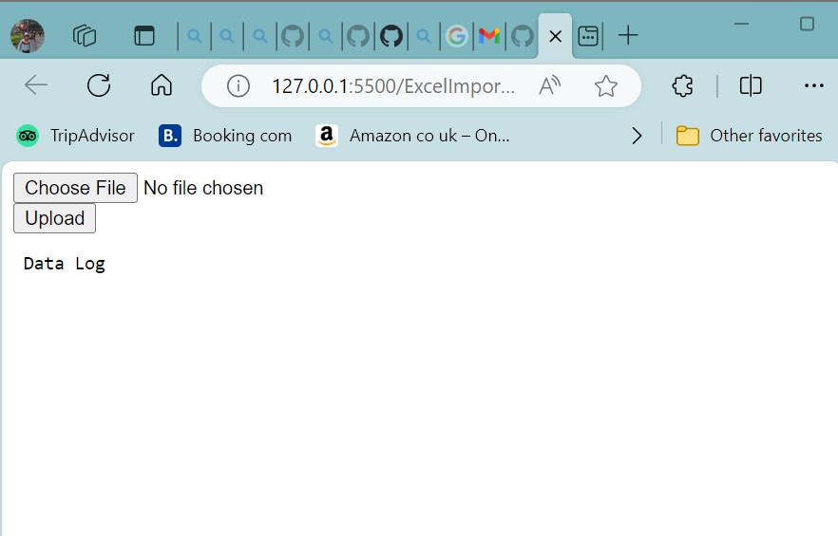

The file is selected by clicking the Choose File Button

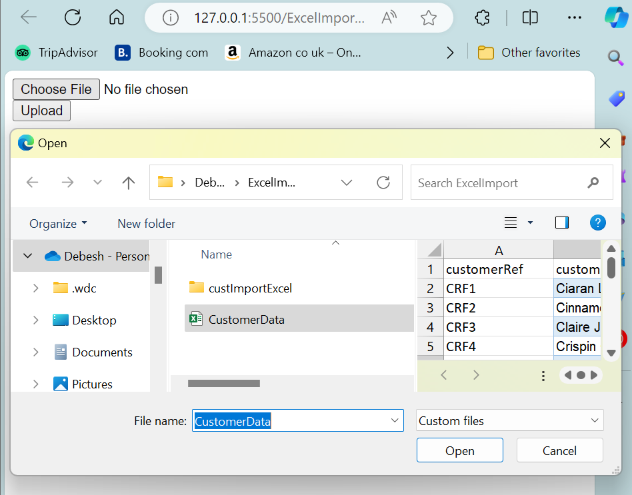

On clicking the Upload Button , each row of the customer data in Excel Sheet is uploaded to the database using a REST API. The result in JSON format is also displayed.

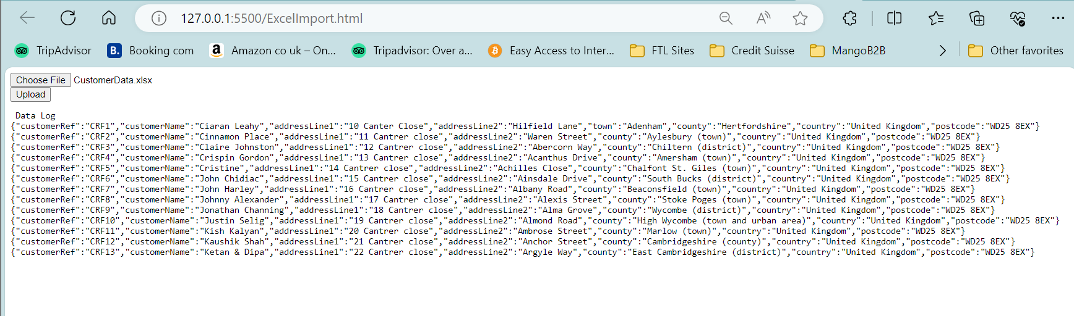

The details may be checked using a swagger docs

